**Week 5**

Servlet program

Screenshots:-

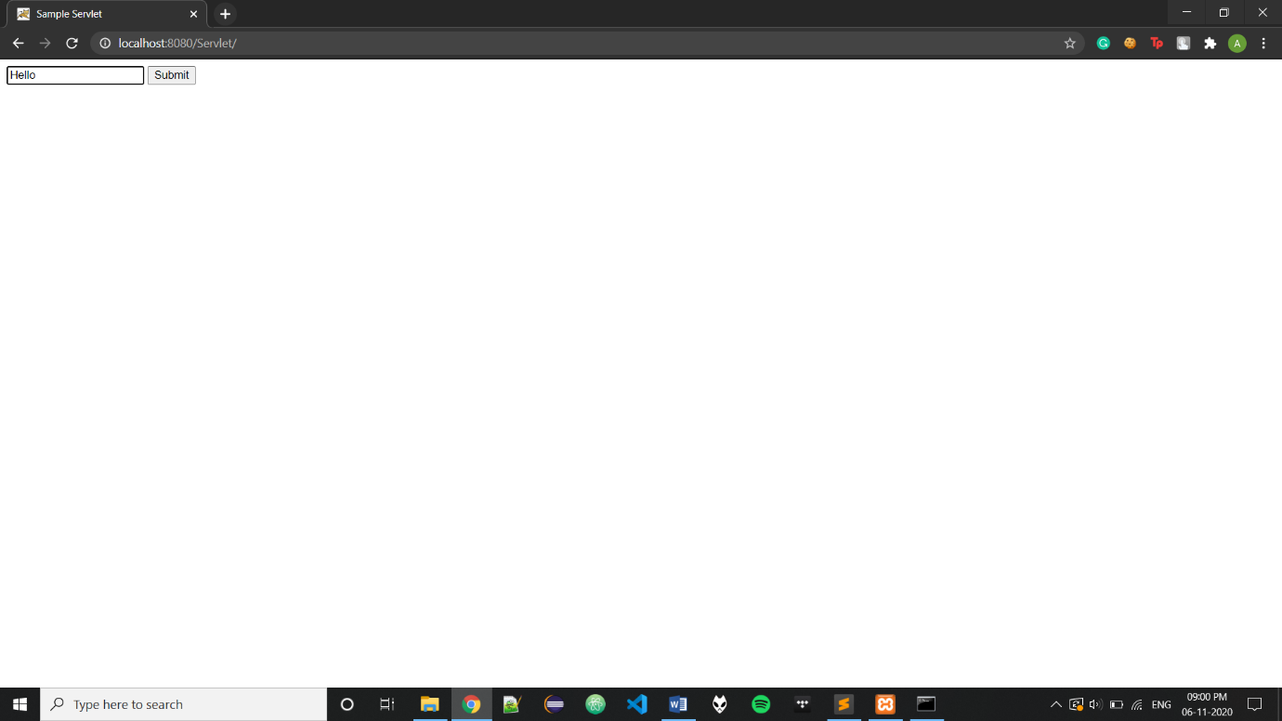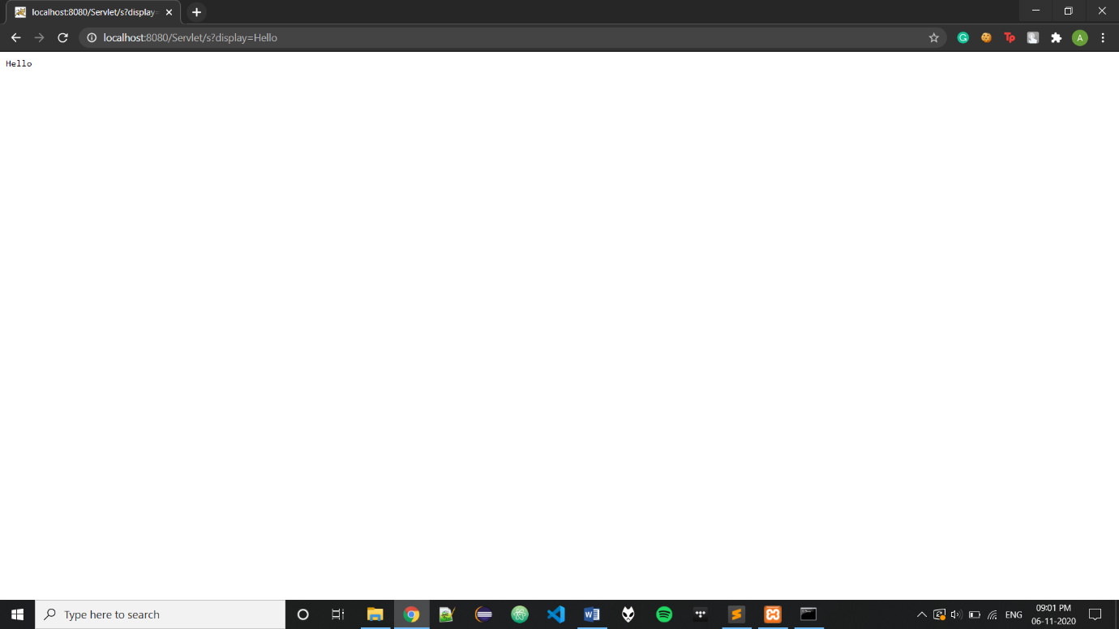

Code:-

import javax.servlet.*;

import javax.servlet.http.*;

import java.io.*;

public class s extends HttpServlet{

public void service( HttpServletRequest req, HttpServletResponse res) throws ServletException, IOException{

String str = req.getParameter("display");

PrintWriter p = res.getWriter();

p.println(str);

}

}